|  |  |  |  |  |  |
| --- | --- | --- | --- | --- | --- |
| Date | 30-Nov-22 | | | Tester Name | Mayuri Patel |
| Environment | Penfax - Test | | | Login used |  |
| Operating System | Select OS | Version: | Update: | | |
| Software Used | Select Software | Version: | Update: | | |
| Select Software | Version: | Update: | | |
| Release version | 22.4.1 | | | | |
| Title |  | | | | |
| Test Type | Regression | | | | |
| Test Scenario | Stop regular payments | | | | |
|  |  | | | | |
| Expected Results |  | | | | |
| Pass/Fail | Pass | | | JIRA# | N/A |

Describe your steps with screenshots:

Find and open member profile to stop regular payment

Go to Benefit Recipient

Select PEPP Income Benefit

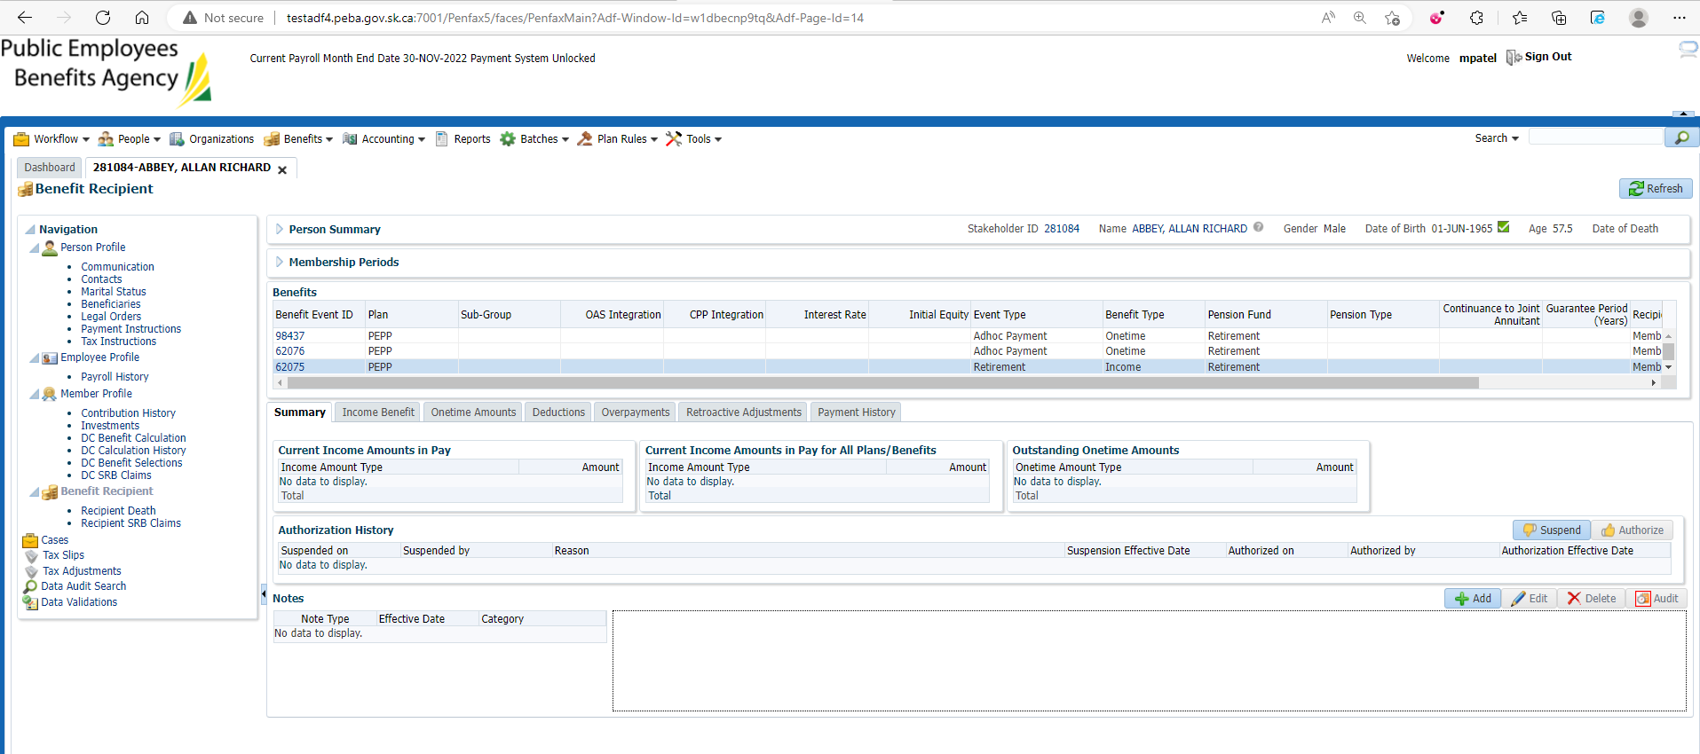

Payment Instruction Under Investments

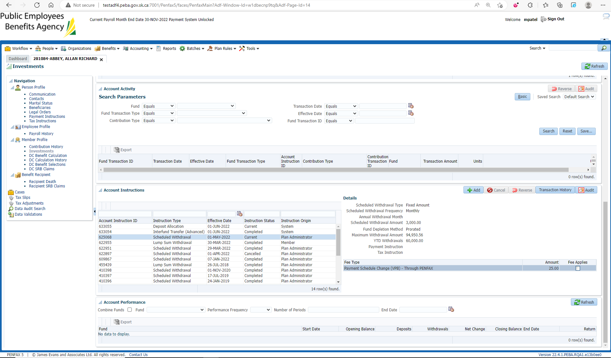

Stop Schedule Withdrawal by Cancelling

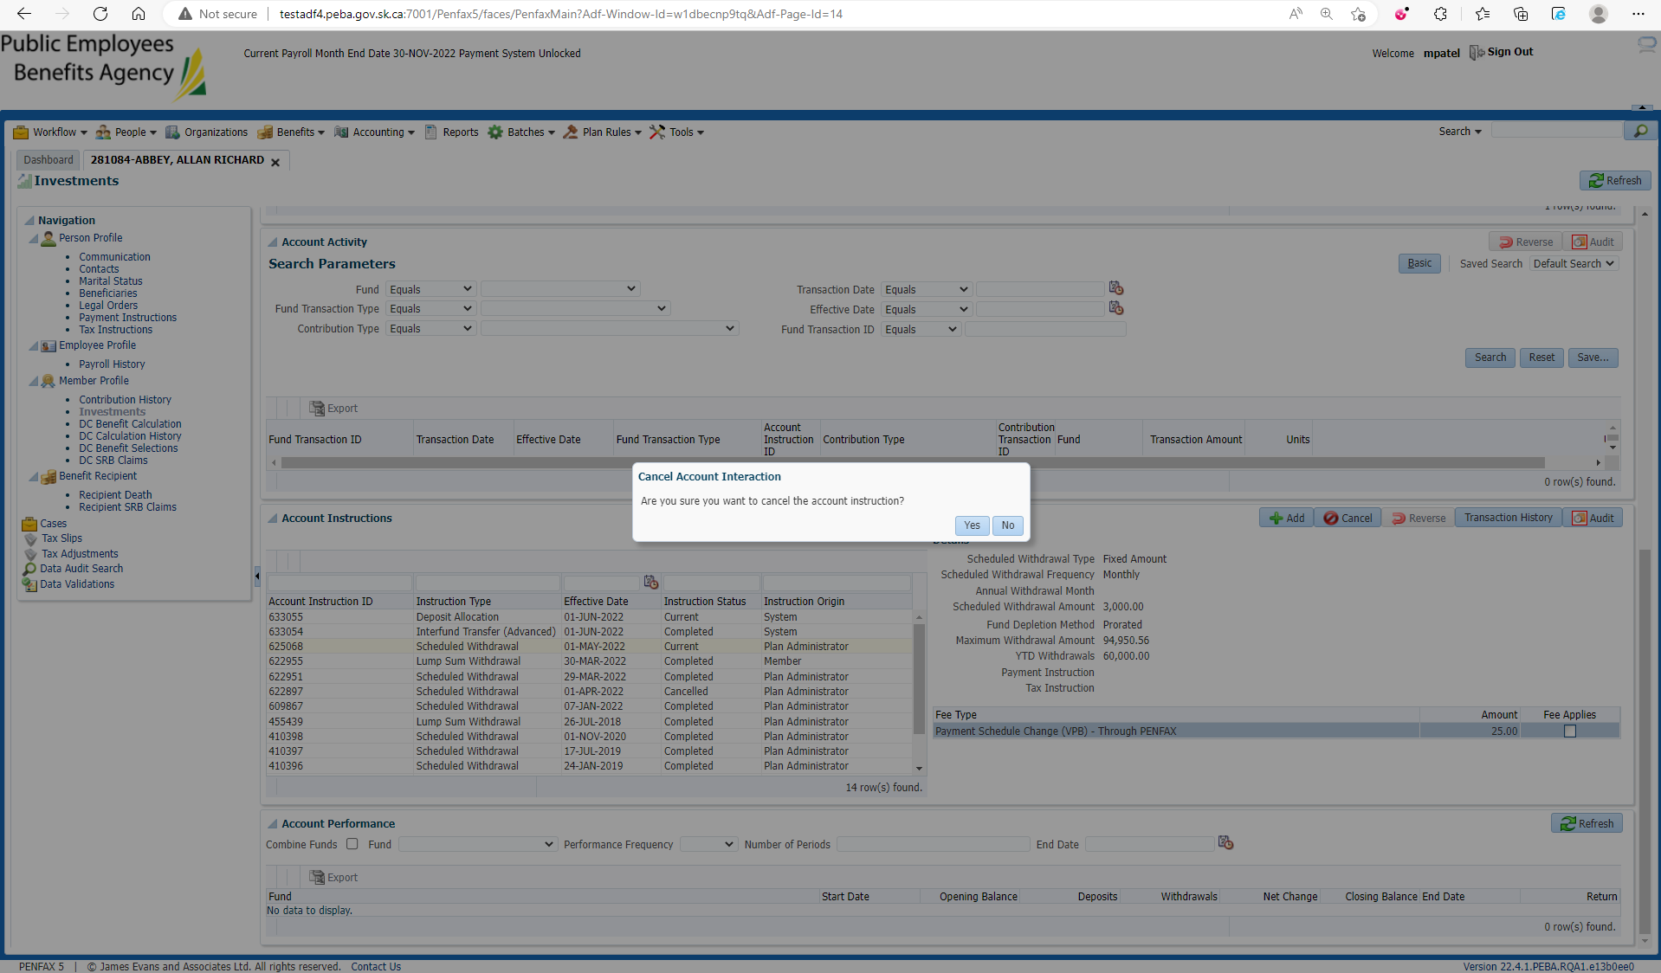

Yes, and Changes are reflected

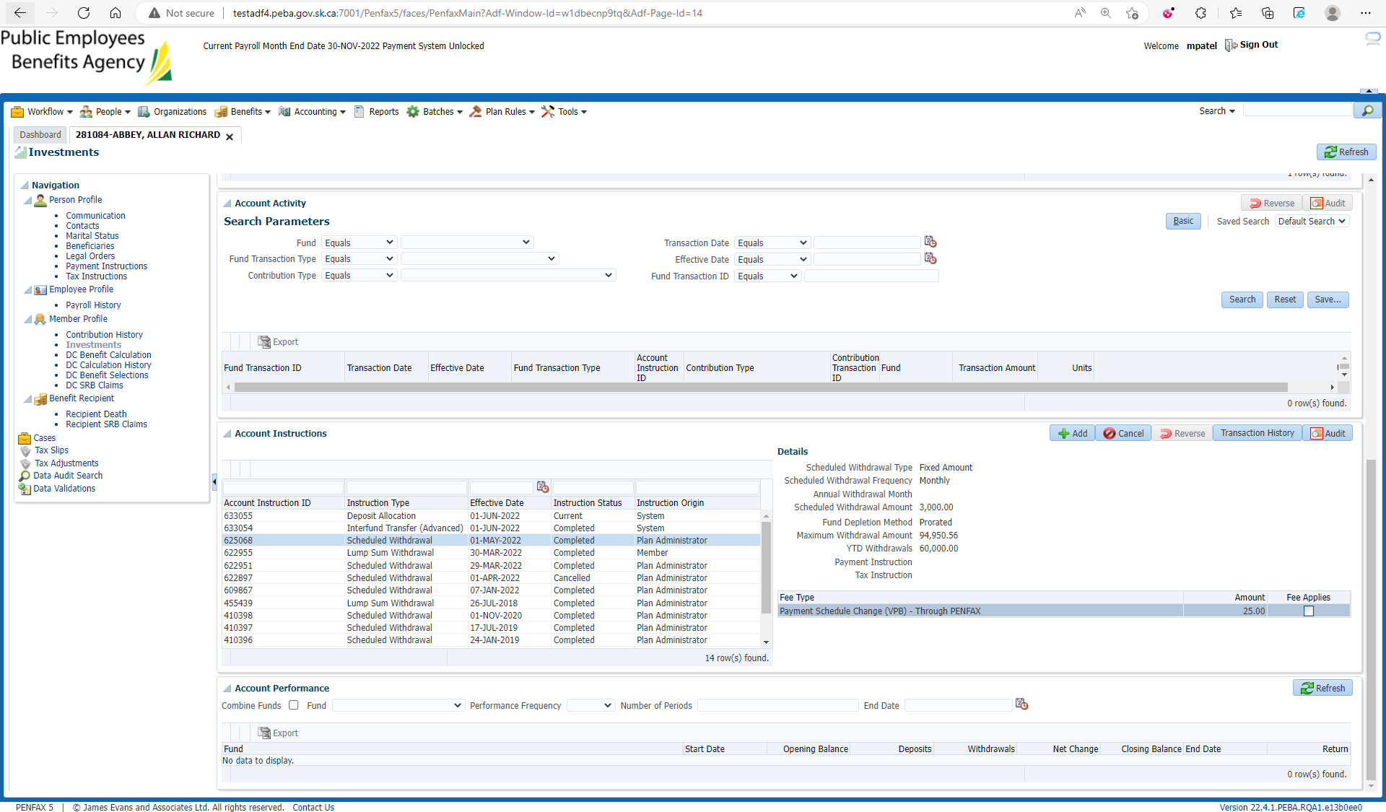

Same steps when processed through Penweb

